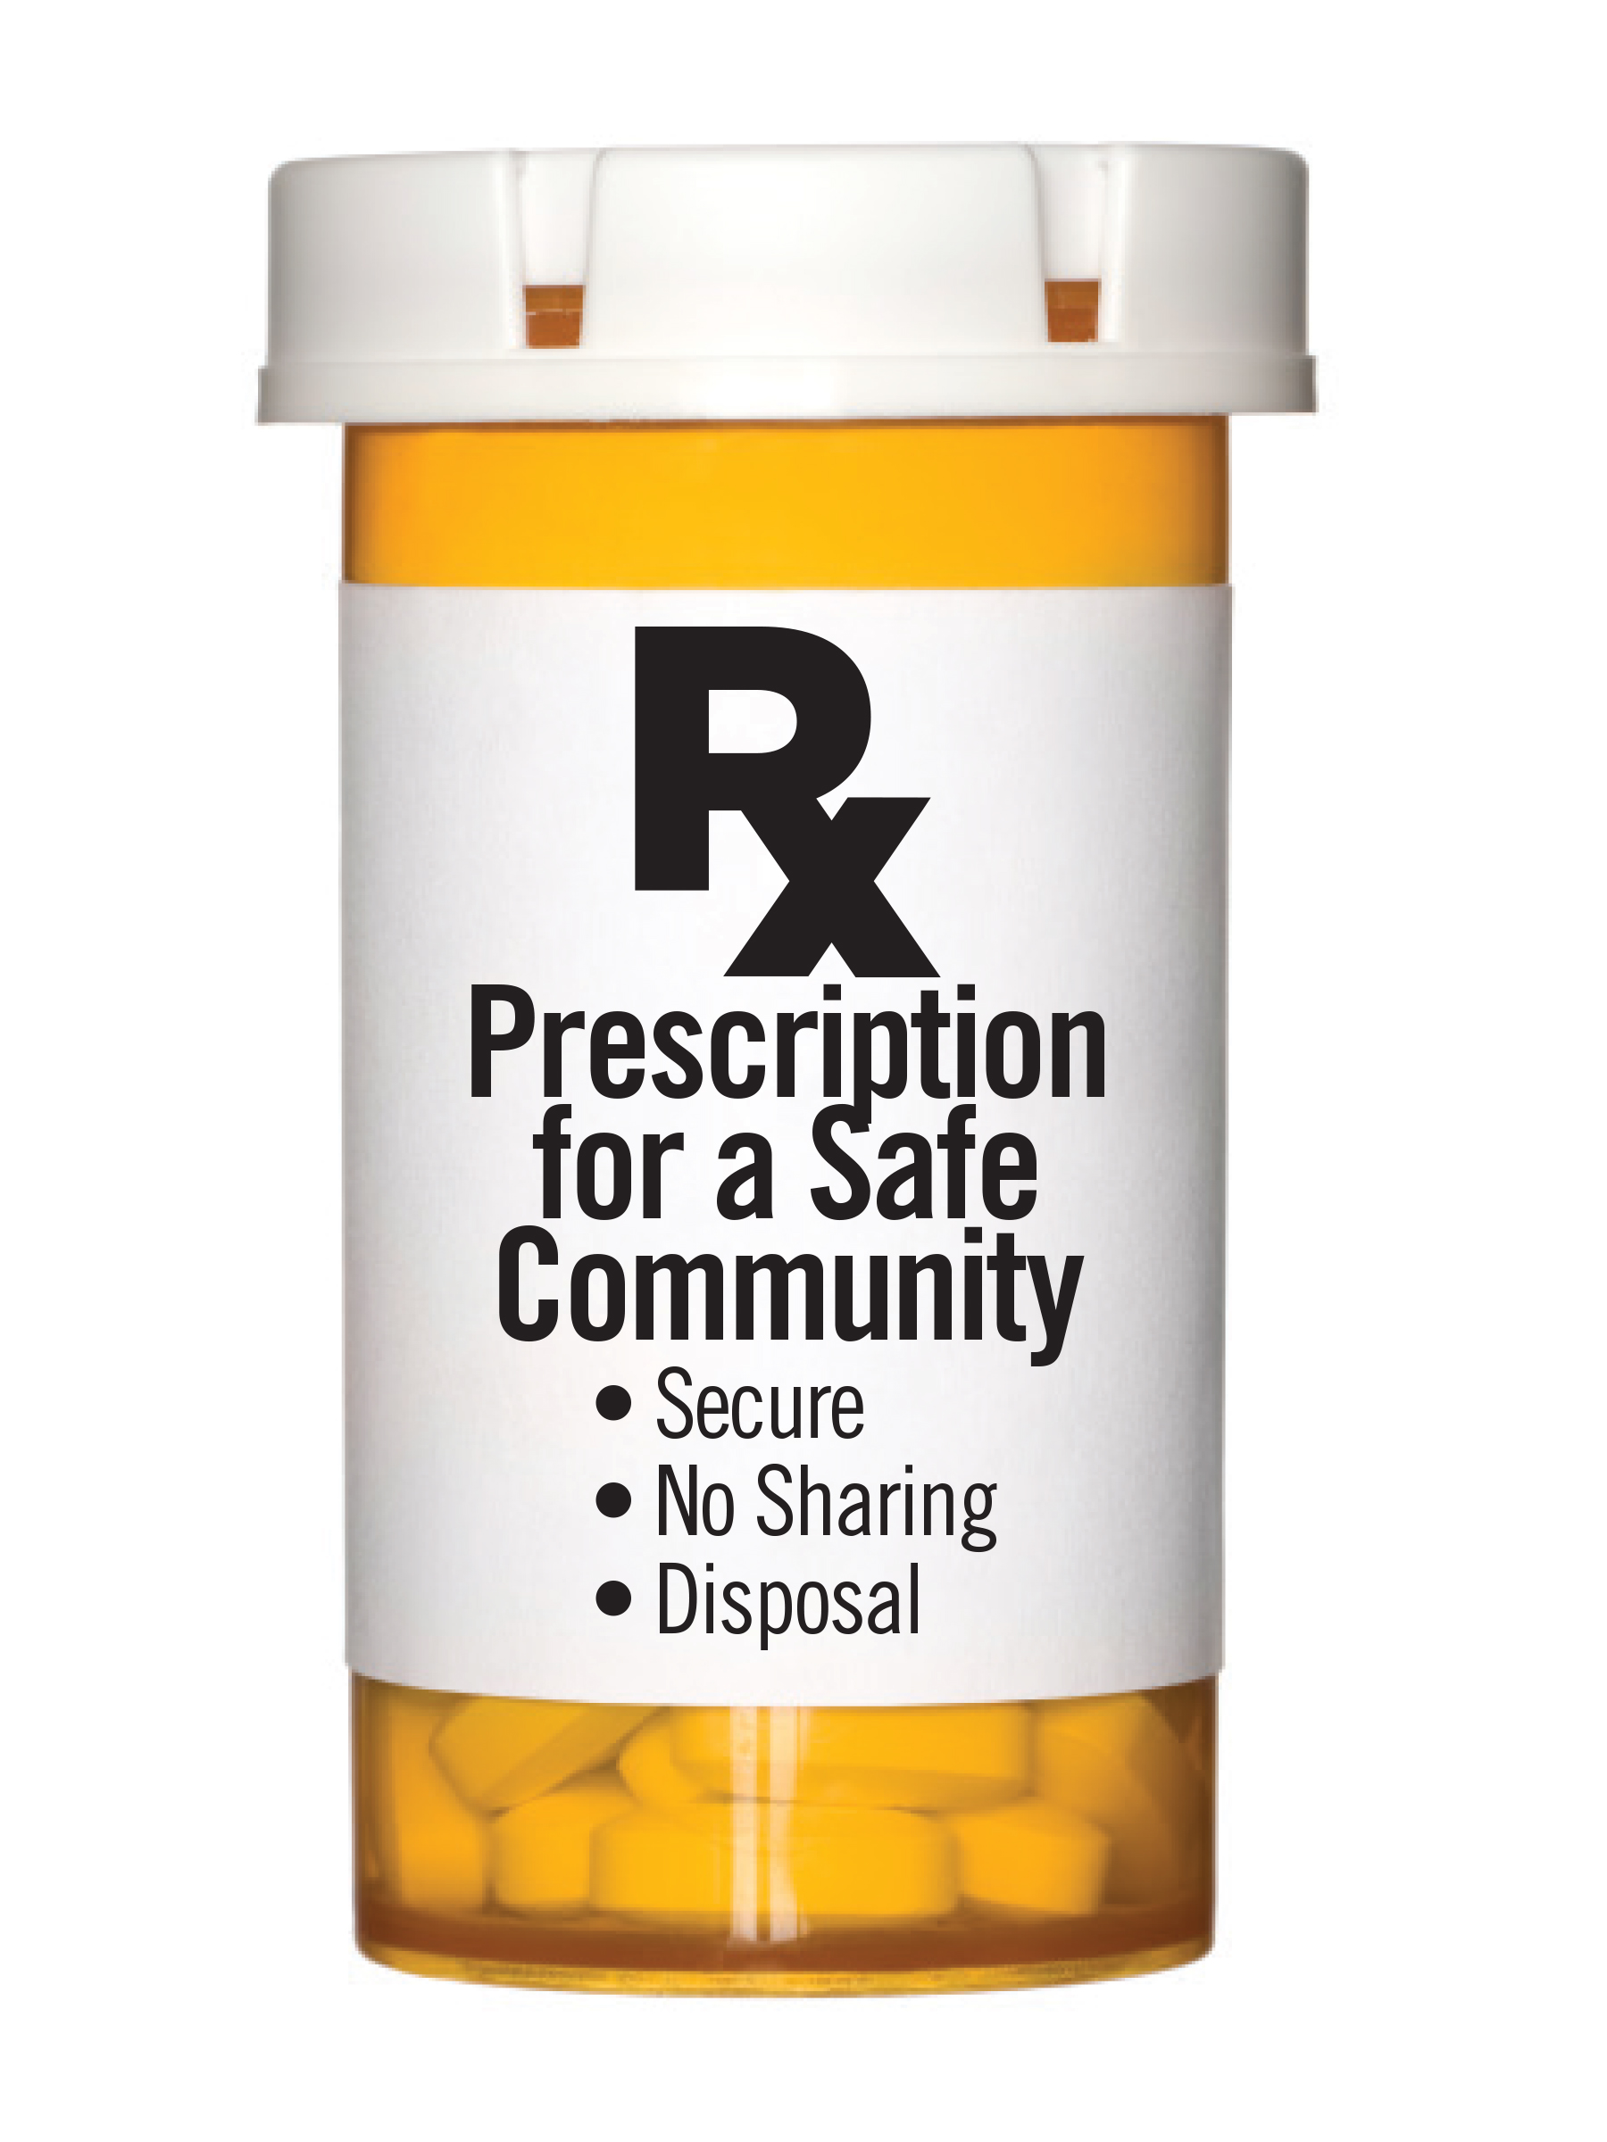
Dentists

Because many people are introduced to prescription drugs to deal with pain resulting from a procedure or injury and others may obtain them from medicine cabinets, family or friends, we would like to ask you as a health care professional to help us in the effort to curb this widespread problem. A few words of wisdom from a patient's own provider would go a long way.

Best Practices:
- Discuss the risks of storing narcotics and other potentially addictive medications at home.
- Where appropriate, consider prescribing fewer pills to decrease the likelihood that they will be given to a friend, sold, stolen, or used after they are no longer necessary.
- Discuss securing medications as soon as possible until the family is able to properly dispose of them.
- Discuss proper disposal of medications
- Provide the drug drop flyers to patients regarding the 13 permanent drug disposal locations in Fond du Lac County.
- Give client/family a Deterra Deactivation Pouches, if they are unable to access a drop box to dispose of medications. Contact DFC if need additional pouches.
- Instruct the family to refrain from flushing medications down the toilet or throwing them away as this is harmful to the environment
Working together as a community helps to create a safe environment for all families.
Thank you for your support of the Drug Take Back campaign.

