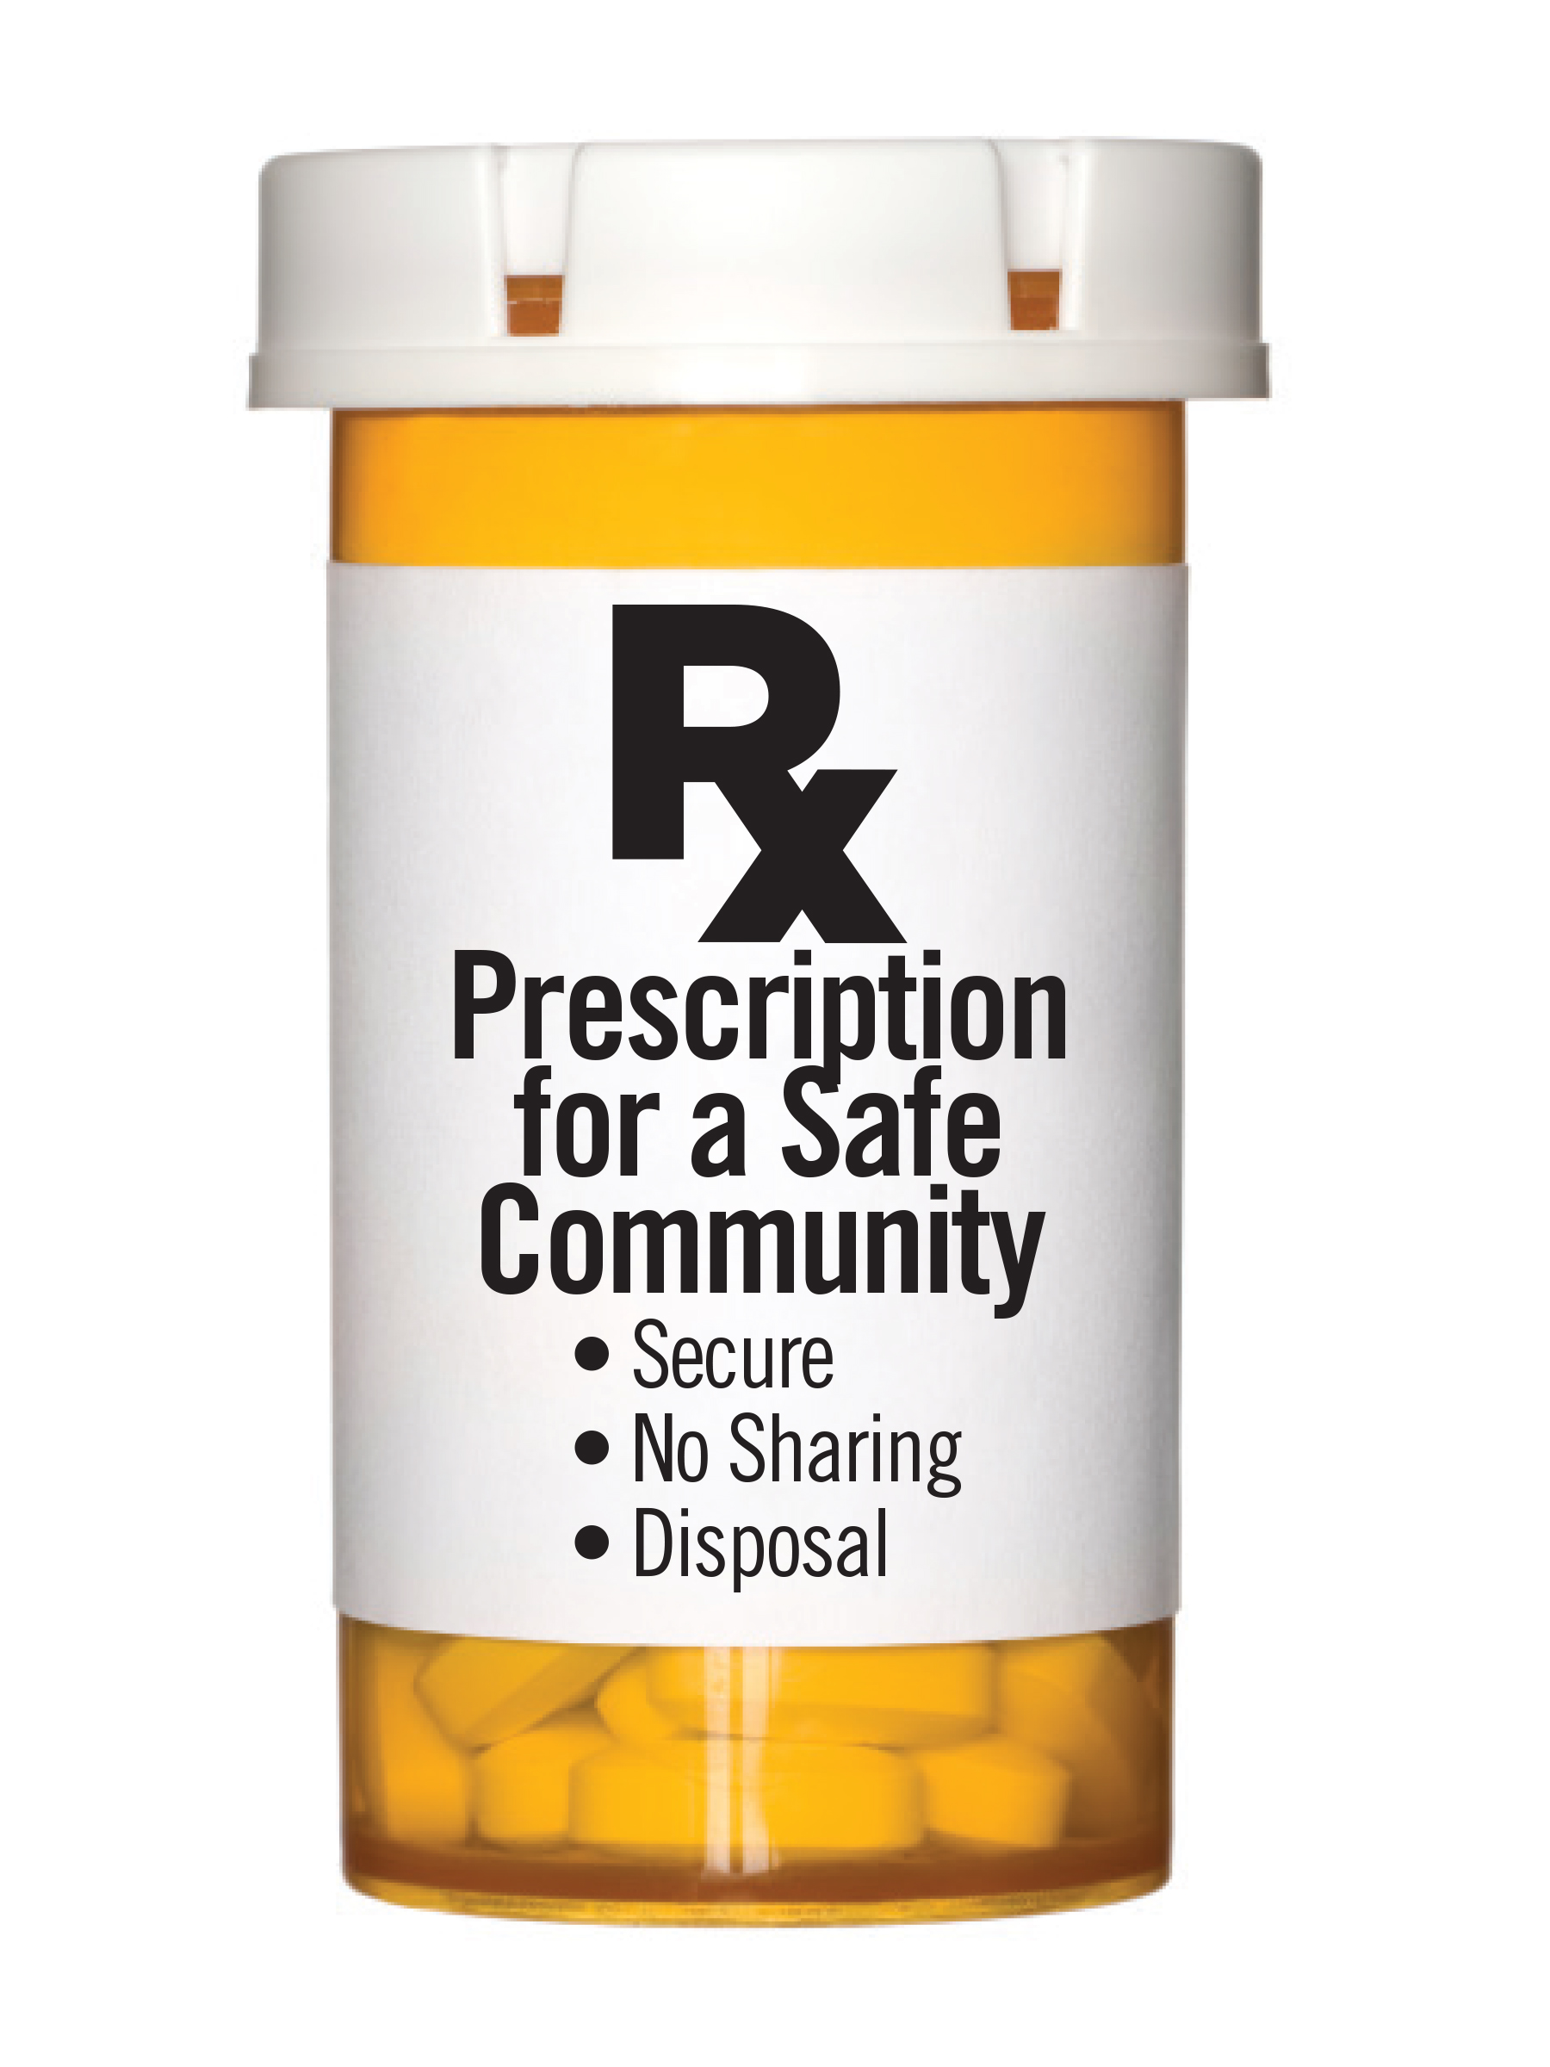
Funeral Directors

There is a potential for medications to be stolen from a home when family members are at their loved one’s wake and funeral. Funeral directors can implement best practices and provide medication safety recommendations to families to reduce the availability of prescription medications and prevent misuse and abuse.

Best Practices:

- Give verbal instruction on medication safety to family members at the initial meeting when discussing safety of valuables.
- Distribute medication safety tips to the family.
- Discuss securing medications as soon as possible until the family is able to properly dispose of them.
- Discuss proper disposal of medications with the family (Secure and Responsible Drug Disposal Act of 2010)

  - Instruct family to dispose of medications through disposal sites or drug drop events in their community

  - Give client/family a Deterra Deactivation Pouches, if they are unable to access a drop box to dispose of medications. Contact DFC if need additional pouches.

  - Instruct the family to refrain from flushing medications down the toilet or throwing them away as this is harmful to the environment
Working together as a community helps to create a safe environment for all families.
Thank you for your support of the Drug Take Back campaign.
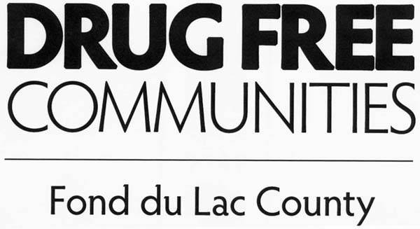
09/2020
This information is provided by Drug Free Communities of Fond du Lac County
920-906-6573. Visit our website: www.csifdl.org/dfc

