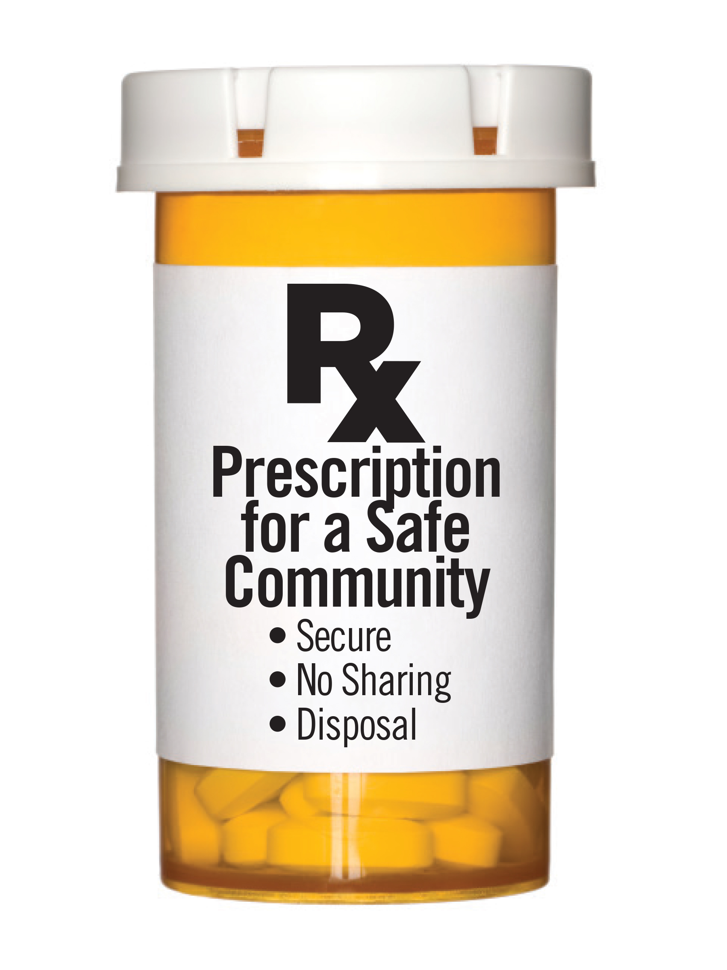

What You Need to Know about Prescription Medication Safety:

Youth in Fond du Lac County that misuse prescription medications most often obtained the medications by taking them from parents or home/medicine cabinets, typically without their knowledge.

Approach securing your prescriptions in the same way you would other valuables in your home, such as jewelry or cash.

REMEMBER THESE MEDICATION SAFETY TIPS:
SECURE – DISPOSAL – NO SHARING

Secure: It is important to keep all medication in a secure location during home showings, open houses and moving days such as:
- An area that is not accessible to children or visitors; out of your bathroom medicine cabinet and kitchen cupboard (these are areas anyone entering your home has access to)
- A lock box or locked filing cabinet
- Use a plastic tote to put your medications and valuables in to take with you as you leave your home
- Know where your valuables and medications are and that they are secure while people are in your home

Disposal: It is no longer acceptable to flush or throw away medication.
- Now is a good time to go through your medications (including pet medications); sort out those that are expired or no longer needed and take them your local disposal site
- Studies show that measurable amounts of medications have been found in drinking water and wildlife due to flushing or throwing them away
- Medication strength changes over time and is not typically safe after one year
- Proper disposal removes medications from your home in a safe way so others do not have access
- Dispose of medications in one of FDL County’s 13 drug drop boxes. Visit www.csifdl.org/dfc to find a drop box site near your. Or contact Drug Free Communities of Fond du Lac County (DFC) to receive a free Deterra Drug Deactivation pouches. Disposes of approximately 45 pills (supply is limited).

Zip through your medicine cabinet and empty your pill bottles into a zip-lock bag. Then zip off to your local drug drop box for disposal.

No Sharing: It is illegal to share your prescription medications, even with a family member.
- The medication was prescribed specifically for you and your body
- You do not know how the medication may affect others physically or emotionally
- It is a criminal offense to share prescriptions

